**PRACTICAL - 4**

**AIM: To study Single-row functions.**

**THEORY:**

**DATE CONVERSION FUNCTION**

If date has to be retrieved or inserted into a table in a format other than default one, Oracle provides TO_DATE and TO_CHAR functions.

**TO_DATE FUNCTION:**

TO_DATE is used to convert character data, or numeric data, into a DATE value. It allows user to insert data into date column in any required format by specifying character value of the data to be inserted and its format.

**Syntax:**

TO_DATE(<char value>,[<fmt>])

where char value stands for the value to be inserted in the date column and fmt is the date format in which char value is specified.

**Examples:**

SELECT TO_DATE('06/07/02','DD/MM/YY') FROM DUAL;

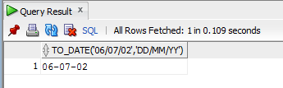

SELECT NAME FROM EMPLOYEE WHERE HIREDATE = TO_DATE('Feb 22,1981','MM DD,YYYY');

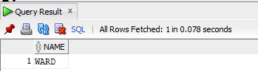

SELECT TO_DATE('06/07','MM/DD') FROM DUAL;

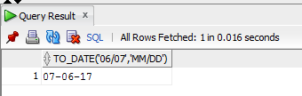

SELECT TO_DATE('06/2013','MM/YYYY') FROM DUAL;

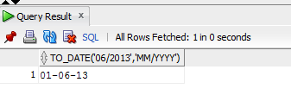

SELECT TO_DATE('06/2013','DD/YYYY') FROM DUAL;

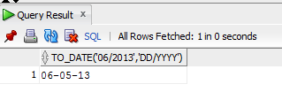

SELECT TO_DATE('06/02','DD/MM') FROM DUAL;

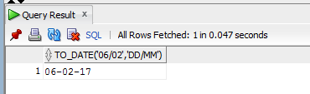

# By default, it takes date as 1st and month/year as system current month/year.

TO_CHAR FUNCTION:

It felicitates the retrieval of data in a format different from the default format. It can also extract a part of date, i.e. the date, month or year from the date value and use it for sorting or grouping of data according to date, month or year.

Syntax:

TO_CHAR(<date value>,[<fmt>])

Examples:

SELECT TO_CHAR(SYSDATE,'DD-MM') FROM DUAL;

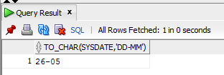

SELECT NAME,TO_CHAR(HIREDATE,'MM')"Hire" FROM EMPLOYEE ORDER BY HIREDATE;

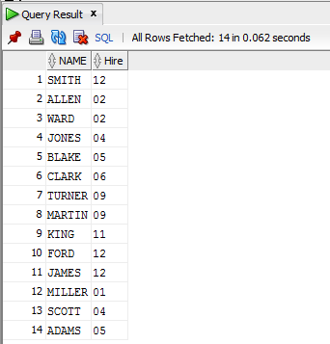

**Special Date formats using TO_CHAR Function:**

Sometimes, the date value is required to be displayed in special formats, for example instead of 03-JAN-81, displays the date as 3rd January 1981. For this, Oracle provides special attributes, which can be used in the format specified with TO_CHAR and TO_DATE functions. Standard syntax available are:

CC *Century*

YYYY Year 1956

YY Year 56

YEAR Year spelled out

BC BC/AD Indicator *

Q Quarter : Jan-Mar=1, Apr-Jun=2

MM Month of year 01, 02…12

MON JAN, FEB

MONTH In full [January ]…[December ]

FMMONTH In full [January]…[December] no trailing spaces

RM Roman Month I, II…XII *

WW Week of year 1-52

W Week of month 1-5

DDD Day of year 1-366 *

DD Day of month 1-31

D Day of week 1-7

DAY In full [Monday ]…[Sunday ]

FMDAY In full [Monday]…[Sunday] no trailing spaces

DY MON…SUN

DDTH Ordinal Day 7TH

DDSP Spell out ordinal One Two etc.

DDSPTH Spell out ordinal SEVENTH

HH Hours of day (1-12)

HH24 Hours of day (1-24)

AM am or pm *

PM am or pm *

A.M. a.m. or p.m. *

P.M. a.m. or p.m. *

MI Minutes 0-59

SS Seconds 0-59 *

SSSSS Seconds past midnight (0-86399) *

Examples:

SELECT NAME,TO_CHAR(HIREDATE,'DDTH-MON')"Hire" FROM EMPLOYEE ORDER BY HIREDATE;

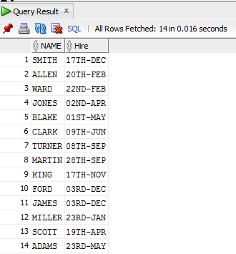

SELECT NAME,TO_CHAR(HIREDATE,'DDSP-MON')"Hire" FROM EMPLOYEE ORDER BY HIREDATE;

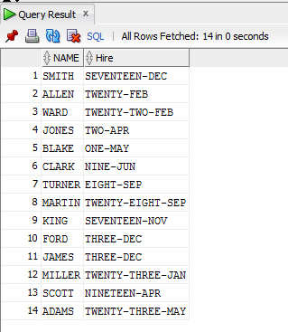

SELECT NAME,TO_CHAR(HIREDATE,'DDSPTH-MON')"Hire" FROM EMPLOYEE ORDER BY HIREDATE;

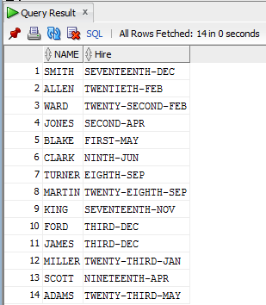

**PROGRAM EXECUTION:**

**Creating Tables:**

To create table Employee:

|  |
| --- |
|  |

**Inserting Data into Tables:**

Insert Data in Employee:

|  |
| --- |
|  |

**Queries to be performed:**

* 1. Write a query to display the current date. Label the column Date.

**Output:**

|  |
| --- |
|  |

* 1. For each employee, display the employee number, Employee Job, and salary increased by 15% and expressed as a whole number. Label the column New Salary.

**Output:**

|  |
| --- |
|  |

* 1. Modify your query no 4.(2) to add a column that subtracts the old salary from the new salary. Label the column Increase.

**Output:**

|  |
| --- |
|  |

(4)Write a query that displays the employee’s names with the first letter capitalized and all other letters lowercase, and the length of the names, for all employees whose name starts with J, A, or M. Give each column an appropriate label. Sort the results by the employees’ last names.

**Output:**

|  |
| --- |
|  |

(5)Write a query that produces the following for each employee: <employee last name> earns <salary> monthly.

**Output:**

|  |
| --- |
|  |

(6) Display the name, hire date, number of months employed and day of the week on which the employee has started. Order the results by the day of the week starting with Monday**.**

**Output:**

|  |
| --- |
|  |

(7) Display the hiredate of emp in a format that appears as Seventh of June 1994 12:00:00 AM.

|  |
| --- |
| select date_format(hiredate," %dth of %m %y") "HIREDATE" from employee1; |

**Output:**

|  |
| --- |
|  |

(8) Write a query to calculate the annual compensation of all employees (sal+comm.).

|  |
| --- |
| select (sal*12+coalesce(comm,0)) 'ANNUAL_COMPESATION' from employee1;  select (sal*12+comm) 'ANNUAL_COMPESATION' from employee1; |

**Output:**

|  |
| --- |
|  |